150+ Midjourney prompts (v4 & v5 versions)
You can change the [main keywords] of the promts in order to get the desired image in the same style.
You can also change the aspect ratio to change the format of the image itself. For example --ar 1:1, --ar 2:3, --ar 3:2, --ar 16:9, --ar 9:16, etc...
For Upscale and Enhance your images I use this AI Tool. I think, it’s the best quality tool to work with Midjourney images.
You can also take this great course Midjourney for Beginners: Step-By-Step Guide to Generating AI Art.
Free 1 month trial period, with access to tens of thousands of other cool courses.

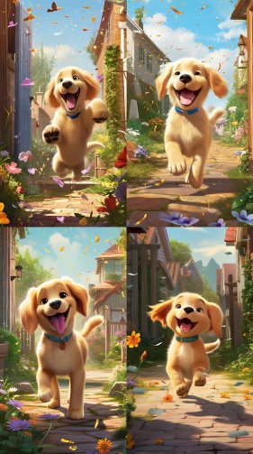 | A Pixar-style digital artwork depicting an energetic Golden Retriever puppy frolicking in a sunlit backyard, featuring a detailed, lifelike yet whimsical interpretation of the puppy with Pixar's signature stylization, expressive eyes, and glossy, textured fur. The backyard teems with colorful details, from butterflies fluttering over a flower bed to a family having a picnic in the background, ultrarealistic render, insanely detailed and intricate --ar 9:16 --v 5
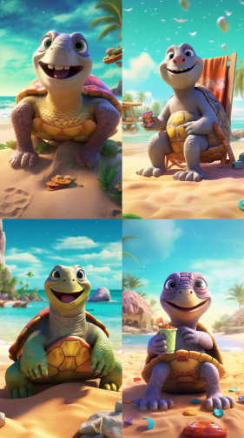 | A delightful Pixar-style digital illustration of a wise old turtle character, lounging on a tropical beach with the glistening ocean in the background. The turtle's wrinkled, smiling face, and its colorful, textured shell stand out against the sandy beach, making it the star of the scene. Incorporate Pixar's signature bright color palette and hyper-realistic texturing, ultrarealistic render, insanely detailed and intricate --ar 9:16 --v 5
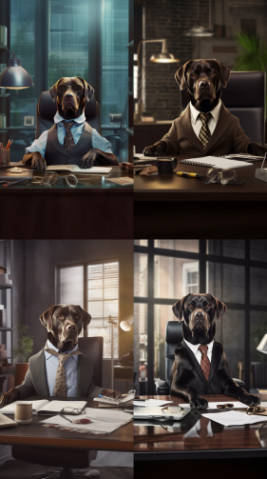 | A vibrant, high-resolution photograph of a dapper Labrador Retriever dressed as a businessman, comfortably seated at a stylish office desk. The Labrador sports a well-tailored suit and classy glasses, looking determinedly at a laptop, exuding an aura of professionalism. The surrounding modern office space is filled with sleek furniture and high-tech accessories, ultrarealistic render, insanely detailed and intricate --ar 9:16 --v 5
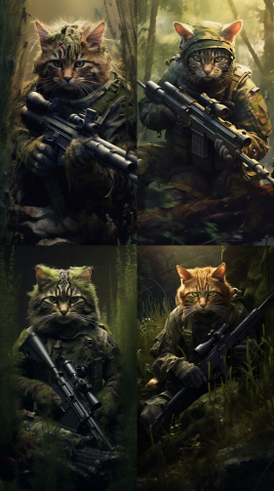 | a cat sniper in military uniform, stealthy, focused, precise, vigilant, camouflage, forest, scope, rifle, scope, shadows, intense, dangerous, mission, precision, accuracy, materials, durable, tactical, sturdy, wide angle, ultrarealistic render, insanely detailed and intricate --ar 9:16 --v 5
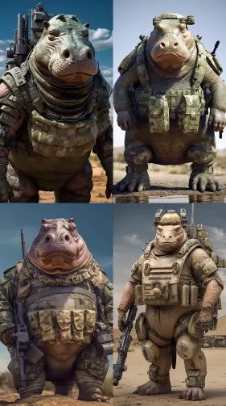 | a hippo in military uniform, formidable, powerful, imposing, sturdy, camouflage, desert, tank, helmet, weapon, strength, determination, mission, courage, materials, rugged, protective, detailed, high-quality, 32k uhd --ar 9:16 --v 5
 | futuristic animal general, with a military uniform and a medal, standing in front of a futuristic army, ultrarealistic render, insanely detailed and intricate --ar 9:16 --v 5
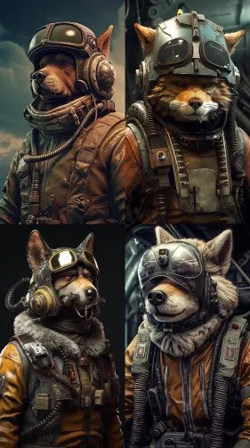 | animal pilot, with a military uniform and a helmet, flying a futuristic fighter jet, ultrarealistic render, insanely detailed and intricate --ar 9:16 --v 5
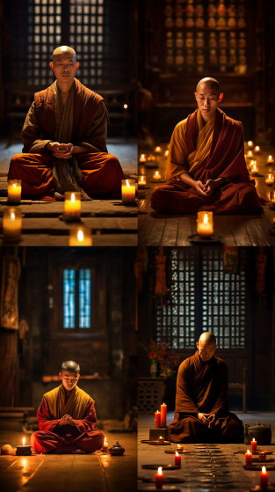 | A deeply moving photograph depicting a young Chinese monk engrossed in prayer, sitting cross-legged on an aged wooden floor within a centuries-old monastery. His robes, vibrant saffron and well-worn, billow gently around him. The tranquility of the environment is palpable, accentuated by dimly lit candles flickering, casting a warm, soft glow on the monk's serene expression, ultrarealistic render, insanely detailed and intricate --ar 9:16 --v 5
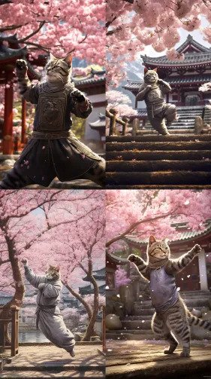 | An intriguing photo capturing a tabby cat in an action-packed wushu pose, juxtaposed against the tranquil backdrop of a monastery garden filled with blooming cherry blossoms. The soft pink petals fluttering around contrast with the vigorous dynamism of the cat. The image captures the spirit of resilience and peace, ultrarealistic render, insanely detailed and intricate --ar 9:16 --v 5
 | horror cyborg assassin, with glowing red eyes and a metal exoskeleton, hunting down its prey in a futuristic city, ultrarealistic render, insanely detailed and intricate --ar 9:16 --v 5
 | futuristic robot cheetah, with glowing eyes and sleek metal fur, running at high speed on a neon-lit track, ultrarealistic render, insanely detailed and intricate --ar 9:16 --v 5
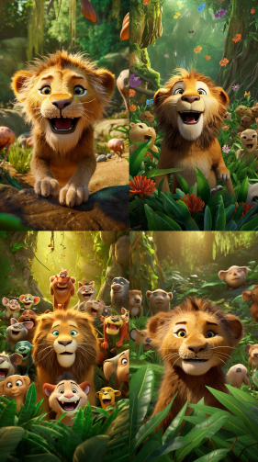 | pixar lion, with big round eyes and a mischievous grin, playing with other animals in a jungle, detailed, high-quality, 32k uhd --ar 9:16 --v 5
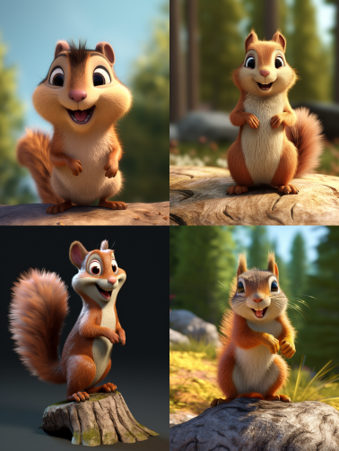 | pixar Squirrel, detailed, high-quality, 32k uhd --ar 9:12 --v 5
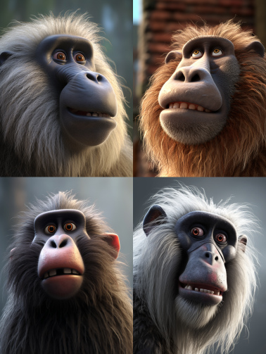 | pixar baboon, detailed, high-quality, 32k uhd --ar 9:12 --v 5
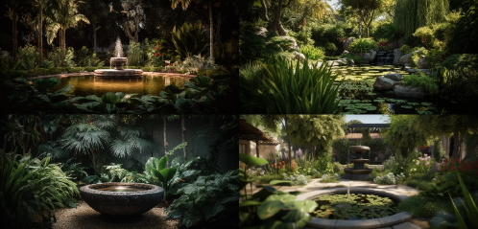 | A garden with a water feature, such as a fountain or waterfall, for a calming ambiance, serene, tranquil, natural, peaceful, relaxing, refreshing, outdoor, meditative, soothing, elegant, atmospheric, reflective, cool, flowing, soundscaped, shaded, contemplative, green, harmonious, 8k --ar 21:10 --v 5
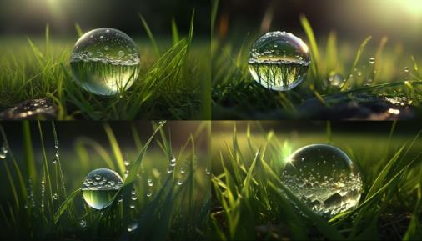 | A beautiful large drop of morning dew in the grass sparkles in the rays of sunlight outdoors in nature, A drop of water on a blade of grass and free space for text, Sparkling, transparent, round, reflective, fresh, green, lush, natural, peaceful, serene, tranquil, calming, mood-enhancing, Render engine: Ray tracing, Camera model: DSLR, Camera settings: f/2.8, 1/250s, ISO 100, 8k --ar 16:9 --v 4
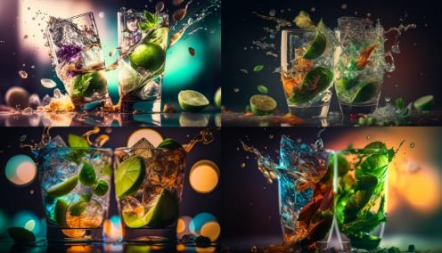 | Collision of two glasses with mojito, glass shards, ice cubes, mint leaves, lime wedges, refreshing, loud, crowded, lively, vibrant, bokeh, shallow depth of field, warm colors, Canon EOS R, f/1.8, ISO 100, 8k --ar 16:9 --v 4
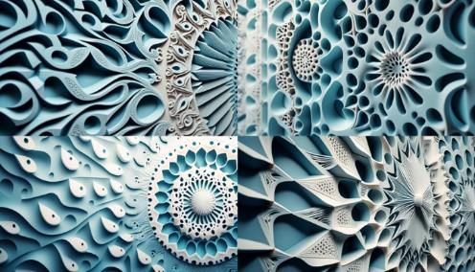 | Textured intricate 3D wall in light blue and white tones, complexity, detail, depth, dimension, innovation, artistry, creativity, contrast, harmony, texture, materiality, lighting, shadow, Canon EOS 5D Mark IV camera settings, 8k --ar 16:9 –v 4
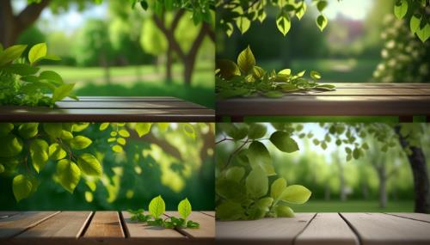 | Spring beautiful background with green juicy young foliage and empty wooden table in nature outdoor, lush, vibrant, fresh, colorful, natural, serene, peaceful, refreshing, outdoors, daylight, foliage, trees, leaves, grass, atmosphere, mood, feelings, joyful, happy, cheerful, delightful, content, technical, 3D render engine, Nikon camera model, aperture priority mode, ISO 100, focal length 50mm, high-resolution image, 8k --ar 16:9 --v 4
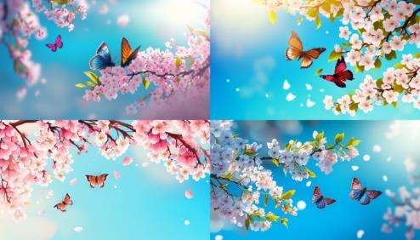 | Spring banner, branches of blossoming cherry against background of blue sky and butterflies on nature outdoors. Pink sakura flowers, dreamy romantic image spring, landscape panorama, copy space, beauty, elegance, delicate, fragrant, natural, peaceful, serene, vibrant, colorful, fresh, crisp, clear, sunny, breezy, tranquil, joyful, playful, romantic, dreamy, idyllic, picturesque, inviting, welcoming, charming, enchanting, mystical, magical, tender, soft, graceful, smooth, detailed, realistic, high-quality, 3D-rendered, digital, camera model: Canon EOS 5D Mark IV, aperture: f/4, shutter speed: 1/320s, focal length: 105mm, ISO: 400, 8k --ar 16:9 --v 4
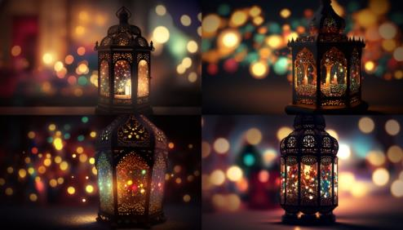 | Original traditional ornate oriental lantern with beautiful bokeh of holiday lights and mosque in background, intricate, colorful, delicate, ornamental, antique, vintage, cultural, festive, cheerful, night, holiday lights, mosque, stars, darkness, mystical, magical, atmospheric, technical, digital, high-quality, professional, render engine, camera model, aperture, exposure time, 8k --ar 16:9 --v 4
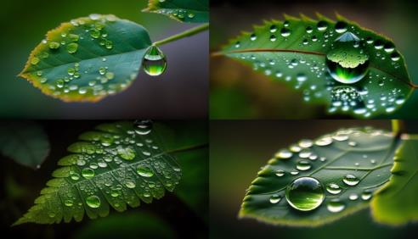 | Large drop water reflects environment, Nature spring photography — raindrops on plant leaf. Water drop, Large, Reflective, Environment, Nature, Spring, Photography, Raindrops, Plant Leaf, Forest, Trees, Foliage, Moisture, Wet, Damp, Fresh, Vibrant, Green, Calm, Serene, Peaceful, Tranquil, Relaxing, Refreshing, Soothing, Technical, DSLR, High Resolution, Shutter Speed, Aperture, ISO, Macro Lens, 8k --ar 16:9 --v 4
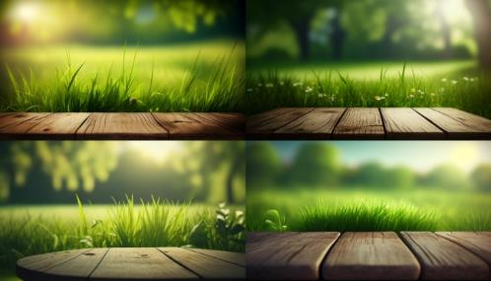 | Beautiful spring natural background with green fresh juicy young grass and empty wooden table in nature morning outdoor, beauty, freshness, vibrancy, natural, outdoor, morning, nature, calm, serene, peaceful, refreshing, new, awakening, camera, bright, sharp, detailed, realistic, 8k --ar 16:9 --v 4
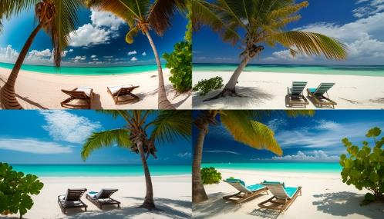 | Beautiful tropical beach with white sand and two sun loungers on background of turquoise ocean and blue sky with clouds. Frame of palm leaves and flowers, paradise, serene, secluded, tranquil, natural, tropical, oceanic, sandy, peaceful, calming, blissful, idyllic, romantic, relaxing, warm, vibrant, colorful, picturesque, breathtaking, dreamy, sunny, refreshing, alluring, inviting, luxurious, comfortable, exotic, secluded, scenic, sunny, pristine, sandy, crystal clear, azure, balmy, gentle, refreshing, soothing, romantic, scenic, heavenly, majestic, serene, calming, nostalgic, evocative, emotional, captivating, stunning, immersive, enchanting, spellbinding, realistic, detailed, high-quality, high-definition, ultra-high-resolution, lifelike, photo-realistic, precise, accurate, state-of-the-art, advanced, sophisticated, modern, professional-grade, 8k --ar 16:9 --v 4
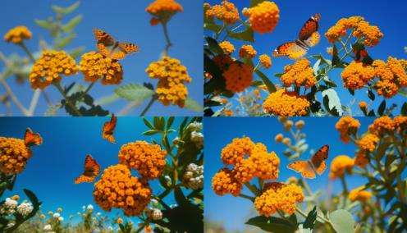 | Natural landscape with many orange lantana flowers and fluttering butterflies Lycaena phlaeas against blue sky on sunny day, colorful, vibrant, lush, natural, beautiful, sunny, blue, orange, fluttering, gentle, peaceful, serene, floral, naturalistic, wild, scenic, outdoors, fresh, crisp, invigorating, joyful, cheerful, warm, delightful, camera, aperture, shutter speed, ISO, focal length, 8k --ar 16:9 --v 4
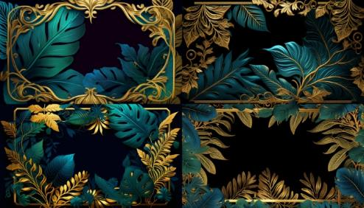 | background frame with golden green and blue tropical leaves. AI generated, opulent, intricate, detailed, vibrant, colorful, exotic, mesmerizing, striking, luxurious, tropical, luscious, deep, elaborate, elaborate, ornate, rich, textured, intricate, dense, mysterious, alluring, romantic, atmospheric, moody, hazy, misty, dreamy, serene, magical, mystical, technical, digital, advanced, high-quality, photorealistic, realistic, lifelike, detailed, precise, advanced, sophisticated, powerful, state-of-the-art, cutting-edge, 8k --ar 16:9 --v 4
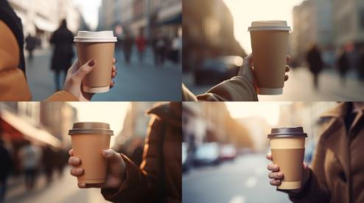 | Female hand holding a paper cup of coffee, to-go style, hot and steaming, portable, convenient, modern, a symbol of busy urban life, depicting a woman on the go, her hand steady and confident, holding the cup with ease, paper sleeve protecting her hand from the heat, brown cardboard texture contrasting with her skin, in the background, a blurred city street, with skyscrapers and cars, suggesting a bustling metropolis, a busy lifestyle, a sense of movement and activity --v 5 --ar 16:9
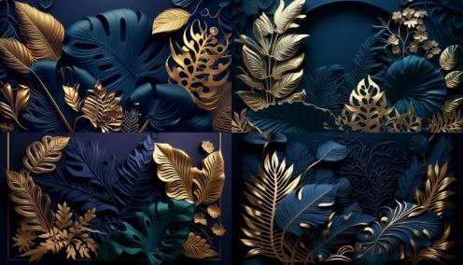 | Beautiful luxury 3D background, in a dark blue hue, with a textured finish, opulent, sophisticated, refined, conveying a sense of luxury and exclusivity, framing a composition of golden, green, and blue tropical leaves, intricate and detailed, vivid and vibrant, adding a touch of nature's exotic beauty to the scene, suggesting a tropical paradise, a lush and vibrant ecosystem, a sense of abundance and richness, with the leaves arranged in an aesthetically pleasing way, creating a harmonious and balanced composition, 8k --ar 16:9 --v 4
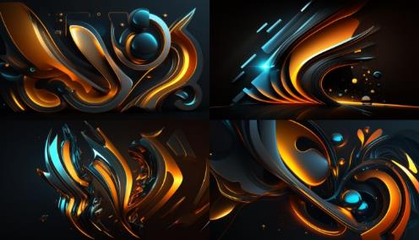 | Beautiful abstract futuristic background, dark and mysterious, evoking a sense of the unknown, the infinite, the possibilities of the future, featuring a neon blue and orange glow, bright and vivid, contrasting with the darkness, creating a mesmerizing and captivating effect, suggesting a world of technology, of innovation, of progress, of new frontiers, with shapes and forms that are dynamic and fluid, yet precise and geometric, conveying a sense of movement, of energy, of transformation, with a touch of surrealism and magic, a vision of a world beyond our current understanding and imagination, 8k --ar 16:9 --v 4
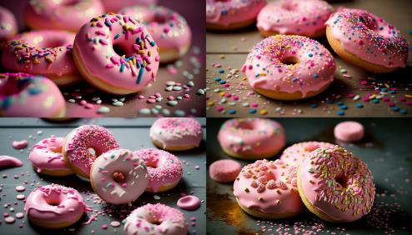 | Pink donuts with sprinkles. Sweet food background, freshly baked donut, delicious, sugary, colorful, round, glazed, yummy, tempting, appetizing, mouth-watering night, dim, soft, warm, cozy, quiet, peaceful, romantic, relaxing mood: happy, joyful, satisfied, content, indulgent, celebratory, festive, playful, carefree, whimsical materials: pastel colors, smooth texture, high gloss, soft lighting, shallow depth of field, 8k --ar 16:9 --v 4
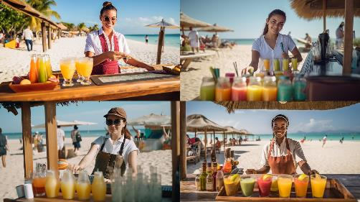 | Waitress serving cocktails on the beach. Young woman in uniform serving cold drinks at a seashore in outdoor cafe or beach bar atmosphere: sunny, breezy, vibrant, lively, refreshing, tropical, leisurely, laid-back, beachy mood: friendly, welcoming, cheerful, attentive, accommodating, professional, efficient materials: wooden bar counter, colorful drinks, beach chairs, umbrellas, sandy beach, blue sea --v 5 --ar 16:9
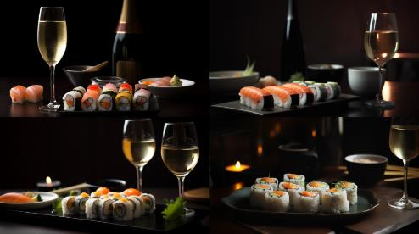 | Sushi rolls and a glass of white sparkling wine. Dinner in a Japanese restaurant, sushi meal with wine food: fresh, raw, savory, delicate, colorful, flavorful, traditional, Japanese, vinegared rice drink: crisp, bubbly, refreshing, light, fruity, white, sparkling, wine atmosphere: modern, elegant, minimalist, cozy, upscale, refined, serene, calming mood: sophisticated, relaxed, indulgent, culinary, adventurous, appreciative materials: wooden table, ceramic plates, chopsticks, wine glass, sake bottle --v 5 --ar 16:9
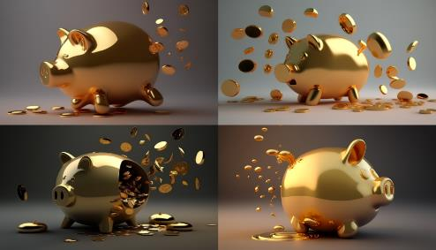 | Golden piggy bank with falling coins object: shiny, metallic, small, cute, decorative, pig-shaped, golden, coin slot action: falling, dropping, tumbling, pouring, scattering, spilling, clinking, bouncing, overflowing atmosphere: bright, cheerful, playful, festive, celebratory, whimsical, joyful, energetic, lively mood: hopeful, optimistic, prosperous, abundant, financially savvy, goal-oriented, practical, thrifty materials: wooden table, white background, shiny coins, Canon EOS R6, 50mm lens, f/4 aperture, studio lighting, 8k --ar 16:9 --v 4
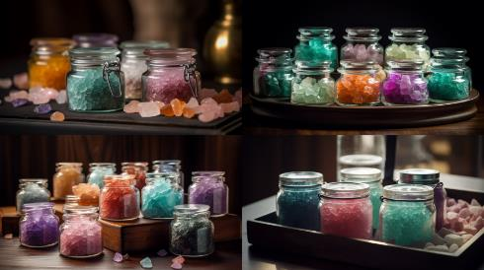 | Crystals in cosmetic jars, colorful sea salt, spa stones objects: translucent, sparkling, small, colorful, natural, mineral, polished, smooth, textured purpose: cosmetic, therapeutic, decorative, aromatic, healing, relaxing, revitalizing, sensory atmosphere: calm, serene, tranquil, soothing, peaceful, meditative, rejuvenating, refreshing mood: indulgent, luxurious, pampering, self-care, holistic, wellness, natural, eco-friendly materials: wooden tray, glass jars, sea salt crystals, spa stones --v 5 --ar 16:9
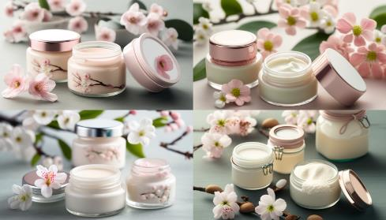 | Natural organic eco cosmetics in open jars with blooming cherry flowers, beauty and SPA theme. Cosmetic containers with cream or lotion, natural ingredients, face care concept objects: eco-friendly, organic, natural, fresh, botanical, nourishing, gentle, rejuvenating, creamy, luscious scenery: cherry blossom, blooming, delicate, pink, fragrant, serene, peaceful, spring atmosphere: spa, relaxing, tranquil, rejuvenating, luxurious, meditative, holistic, pampering, calming mood: indulgent, self-care, nurturing, beauty, wellness, natural, eco-friendly, ethical materials: wooden tray, glass jars, cream or lotion, botanical ingredients, Canon EOS R6, 50mm lens, f/2.8 aperture, diffused lighting, 8k --ar 16:9 --v 4
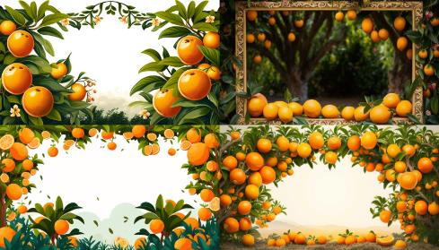 | Border made of orange trees. Oranges hanging on branches making a frame in the garden with space for text scenery: greenery, garden, nature, fresh, vibrant, lush, botanical, fragrant, Mediterranean objects: oranges, ripe, juicy, round, citrusy, colorful, textured, healthy, natural border: natural, organic, lush, textured, bountiful, fruitful, fragrant, charming, picturesque atmosphere: sunny, bright, warm, breezy, inviting, refreshing, cheerful, relaxing mood: inviting, welcoming, lively, flavorful, healthy, natural, rejuvenating, cheerful materials: green grass, orange trees, blue sky, Canon EOS R5, 35mm lens, f/2.8 aperture, natural lighting, 8k --ar 16:9 --v 4
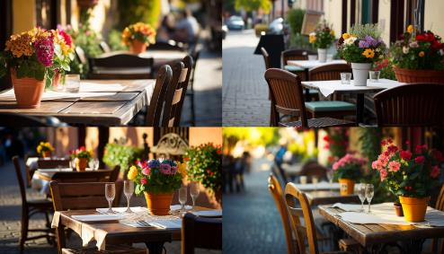 | Empty tables with flowers in outdoor cafe or restaurant objects: tables, chairs, flowers, vases, placemats, napkins, glassware scenery: outdoor, cafe, restaurant, urban, street, European, charming, picturesque, inviting atmosphere: sunny, breezy, vibrant, lively, leisurely, laid-back, relaxed, cheerful, welcoming mood: peaceful, quiet, romantic, intimate, cozy, elegant, sophisticated, modern, refined materials: wooden tables, metal chairs, flower arrangements, Canon EOS R5, 50mm lens, f/2.8 aperture, warm lighting, 8k --ar 16:9 --v 4
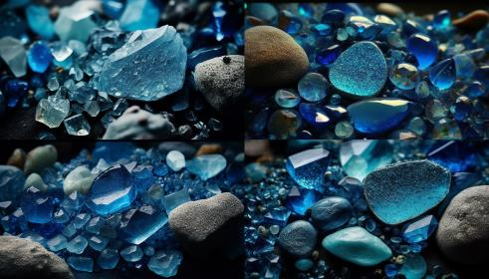 | Blue stones sparkling crystals texture, crystal stone, natural abstract background objects: stones, crystals, texture, abstract, natural, geological, mineral, polished, sparkling scenery: natural, abstract, background, textured, organic, colorful, vibrant, dynamic atmosphere: peaceful, serene, tranquil, soothing, meditative, calming, mysterious, otherworldly mood: introspective, contemplative, imaginative, creative, spiritual, mindful, curious, adventurous materials: blue stones, crystal stone, Canon EOS R5, 100mm lens, f/2.8 aperture, natural lighting, 8k --ar 16:9 --v 4
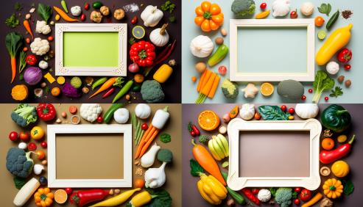 | Empty frame in the middle of different vegetables lying on the table, top view, vegetable food background with empty space in the center, flat lay of various types of vegetables objects: vegetables, table, frame, food, empty space scenery: top view, flat lay, colorful, vibrant, fresh, natural, textured, organic atmosphere: bright, cheerful, inviting, lively, healthy, nutritious, appetizing, wholesome mood: culinary, creative, healthy, natural, fresh, wholesome, vegetarian, eco-friendly materials: wooden table, variety of vegetables, empty frame, Canon EOS R6, 50mm lens, f/4 aperture, natural lighting, 8k --ar 16:9 --v 4
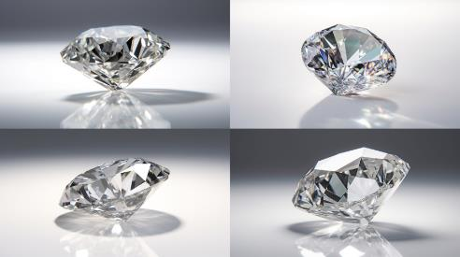 | Diamond jewel on white background closeup. Beautiful sparkling shining diamond with reflective surface object: diamond, jewel, precious, clear, sparkling, shining, brilliant, reflective, faceted scenery: white background, close-up, macro, detailed, elegant, sophisticated, luxurious, minimalist atmosphere: bright, clean, simple, sophisticated, elegant, refined, timeless, classic, modern mood: glamorous, romantic, exquisite, refined, luxurious, celebratory, special, elegant materials: white background, diamond jewel --v 5 --ar 16:9
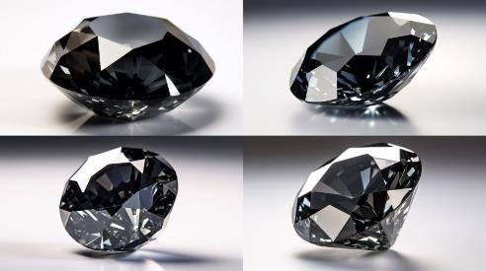 | Black diamond jewel on white background closeup object: diamond, jewel, precious, black, sparkling, shining, brilliant, reflective, faceted scenery: white background, close-up, macro, detailed, elegant, sophisticated, luxurious, minimalist atmosphere: bright, clean, simple, sophisticated, elegant, refined, timeless, classic, modern mood: glamorous, mysterious, exquisite, refined, luxurious, celebratory, special, elegant materials: white background, black diamond jewel --v 5 --ar 16:9
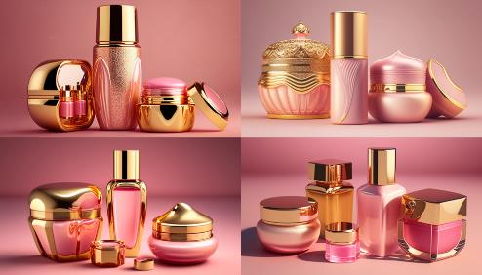 | Beauty products, pink and gold cosmetic containers on pink background, beautiful female perfumes, cosmetics. Luxurious, shimmering, extravagant, expensive, elegant, modern, high-end, glamorous. Night, artificial light, dim, mysterious, intimate, romantic. Alluring, captivating, dreamy, enchanting. Materials, glass, metal, plastic, glossy, reflective, smooth. Camera settings, high resolution, shallow depth of field, soft focus, warm tone, cinematic, 8k --ar 16:9 --v 4
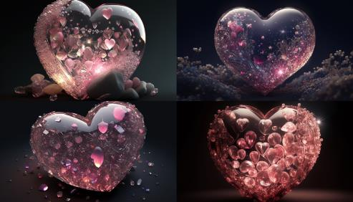 | pink heart of crystals, shimmering, delicate, sparkling, precious, beautiful, magical, enchanted, night, stars, moon, sky, mysterious, dreamy, surreal, mystical, materials, light, shadows, reflections, colors, textures, camera settings, aperture, focal length, exposure, ISO, resolution, lens, render engine, depth of field, perspective, 8k --ar 16:9 --v 4
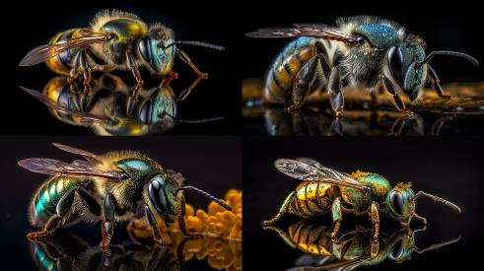 | Capture a breathtaking image of a beautiful BEE resting on a reflective surface, showcasing the iridescent scales in a stunningly detailed manner. Utilize a professional camera, such as the Nikon D850, paired with a 105mm f/2.8 macro lens to achieve an extreme close-up that reveals the intricate details of the BEE's fur and eyes. Employ a dynamic composition and a tilt-shift angle to add depth and interest to the image. The photograph should exude vibrant, highly saturated colors in shades of pastel pink, blue, green, lavender, and peach, as well as an ultra-sharp focus on the mesmerizing, colorful features. Set the aperture to f/8, the shutter speed to 1/250s, and the ISO to 400 for optimal results. Take inspiration from renowned macro photographers such as Thomas Shahan and Nicky Bay to create an 8K, visually captivating image that celebrates the beauty of nature. --ar 16:9 --v 5
 | A captivating 3D-rendered scene featuring a highly-detailed humanoid robot with advanced AI, contemplating its thoughts, a holographic neural network projected around its head, showcasing the complexity of its cognition, set within a modern, futuristic laboratory, vivid colors and sharp textures highlighting the technological marvel --ar 16:9 --v 5
 | Artificial intelligence, a humanoid cyber human with a neural network thinks, as it ponders the mysteries of the universe. It stands among a cityscape filled with futuristic buildings, neon lights reflecting off its metallic skin. The cyber human's eyes emit a warm, glowing light, symbolizing the depth of thought and wisdom within. Photo taken by Yousuf Karsh with a Hasselblad H6D-100c and a 90mm lens, Award Winning Photography style, Studio lighting and Volumetric lighting, 8K, Ultra-HD, Super-Resolution --ar 16:9 --v 5
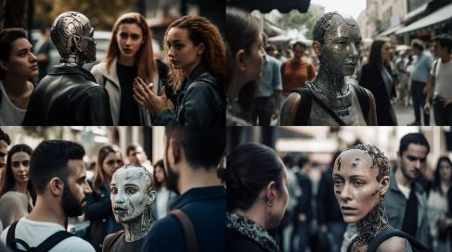 | Artificial intelligence, a humanoid cyber human with a neural network thinks, while interacting with a group of people in a lively, urban setting. The AI's face displays a range of emotions, showcasing its ability to understand and connect with humans on a deeper level. Photo taken by Platon Antoniou with a Fujifilm GFX 100 and a 110mm lens, Award Winning Photography style, Cinematic lighting and Softbox lighting, 8K, Ultra-HD, Super-Resolution --ar 16:9 --v 5
 | A captivating close-up portrait of a humanoid robot with a state-of-the-art exoskeleton and lifelike facial features, emphasizing the intricate mechanics and design elements, set against a futuristic cityscape backdrop, the warm city lights providing a soft, contrasting glow, Canon RF 85mm f/1.2L USM DS lens, ISO 200, f/1.8, 1/100s --ar 16:9 --v 5
 | A photo of a battle-worn humanoid robot with prosthetic limbs and built-in weaponry, standing amidst the ruins of a destroyed city. The robot's damaged exterior tells a story of fierce battles and endless wars, highlighting its resilience and fighting spirit. The lighting used to capture the photo emphasizes the robot's silhouette, casting deep shadows across the broken concrete and steel. Photo taken with Canon EOS R6 and an 85mm f/1.4 lens, 8K, Ultra-HD, Super-Resolution --ar 16:9 --v 5
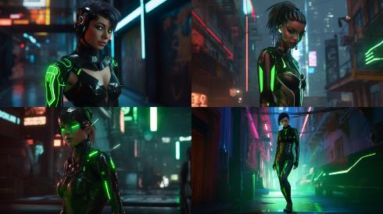 | A female cyborg with a futuristic fashion sense, combining technology with style, wearing a neon green and black bodysuit that illuminates her circuitry, with a holographic visor that displays her vital stats and surroundings. She has metallic, spider-like limbs that move with mechanical precision and speed. The environment is a dimly lit, neon-soaked alleyway, with graffiti-covered walls and steam rising from the ground. The atmosphere is tense and dangerous, with the sound of distant sirens and the smell of oil and rust. The realization will be a digital illustration with a cel-shaded style. --ar 16:9 --v 5
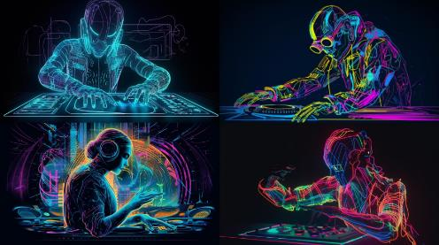 | A cyber-human DJ with neon circuits pulsating to the rhythm, effortlessly manipulating holographic controls to mix a mesmerizing symphony of electronic beats,3D, watercolour and ink drawing, backlit, vivid color, smooth texture, --ar 16:9 --v 5
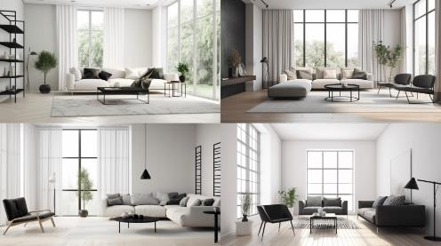 | A sleek, high-quality photo of a minimalist living room, showcasing a monochromatic color scheme, clean lines, and uncluttered space, with stylish modern furniture, geometric patterns, and subtle textures, a large window providing ample natural light that highlights the simplicity and elegance of the room --ar 16:9 --v 5
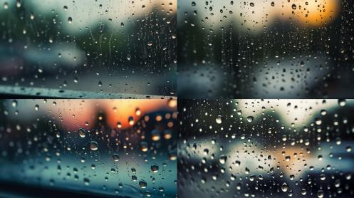 | A striking close-up photograph of glistening raindrops on a windowpane, the droplets catching and reflecting the soft light, creating a dreamy and calming atmosphere. The blurred background showcases a serene, rain-soaked landscape, further emphasizing the delicate beauty of the raindrops --ar 16:9 --v 5
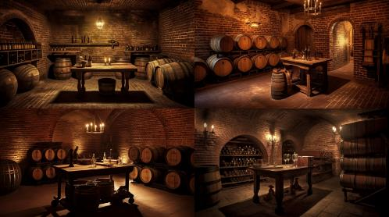 | A beautifully lit photograph of an atmospheric wine cellar, rows of oak barrels aging fine wine, soft ambient lighting casting warm, inviting shadows on the brick walls, cobblestone flooring, adding depth and texture to the scene, a rustic wooden table with a vintage corkscrew and a few open bottles of wine as the centerpiece, evoking a sense of history and tradition --ar 16:9 --v 5
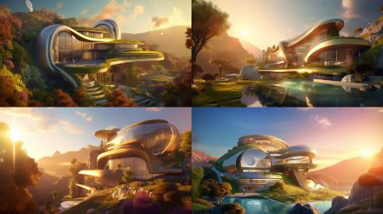 | Futuristic mansion house villa concept art illustration, presenting a harmonious fusion of nature and technology, with elegant, curvilinear architecture that blends seamlessly into a verdant hillside, showcasing the integration of smart home systems, vertical gardens, and solar panels, bathed in the golden glow of a setting sun that reflects off the expansive windows and water features, creating a serene atmosphere --ar 16:9 --v 5
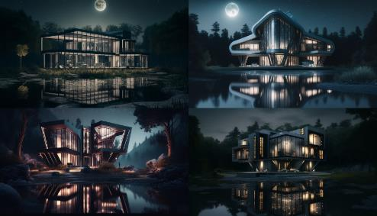 | futuristic mansion house villa, luxurious, spacious, high-tech, sleek, metallic, modern, extravagant, panoramic view, moonlit night, starry sky, tranquil lake, dense forest, mysterious, eerie, haunting, suspenseful, cinematic, technical basis, Ray Tracing render engine, Canon EOS R6 camera model, F2.8 lens, 20mm focal length, ISO 1600, 15-second exposure --ar 16:9 --v 4
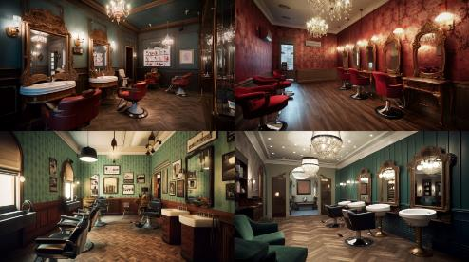 | vintage hair salon interior design, retro, chic, elegant, sophisticated, glamorous, ornate, cozy, classic, timeless, stylish, vibrant, colorful, patterned wallpaper, antique mirrors, chandeliers, plush velvet seating, barber chairs, polished hardwood floors, vintage hair styling tools, old-fashioned signage, ambient lighting --ar 16:9 --q 2 --v 5
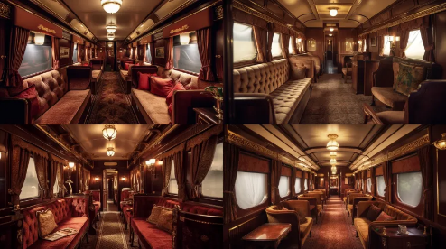 | luxury train interior, plush velvet seats, ornate golden details, dimmed warm lighting, soft carpeted floors, vintage luggage racks --ar 16:9 --v 5
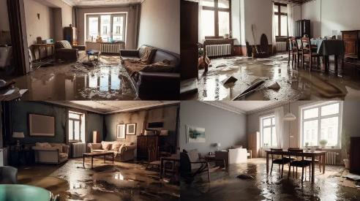 | flooded apartment interior, murky water, floating debris, damp walls, ruined furniture, musty smell --ar 16:9 --v 5
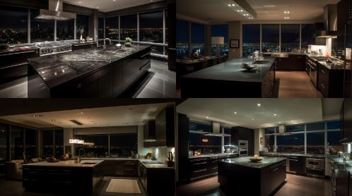 | luxury penthouse kitchen at night, sleek, modern, stainless steel appliances, marble countertops, warm lighting, spacious, high ceilings, cityscape, glass walls, quiet, calm, relaxed, serene, sophisticated, elegant, stylish, moody, shadowy, contrast, technical details, camera model, aperture, ISO, shutter speed, depth of field, low light performance --ar 16:9 --v 5
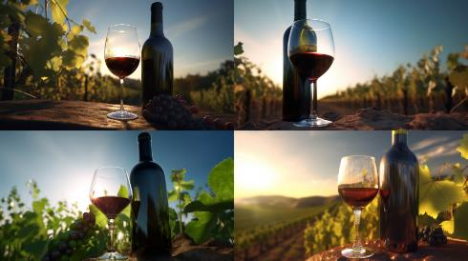 | wine bottle and glass of wine in vineyard, clear glass bottle with red wine, half-filled wine glass, green vine leaves, yellow sun, blue sky, peaceful, serene, romantic, warm, inviting, rustic, natural, 3D model, high-resolution, Nikon camera, shallow depth of field --ar 16:9 --v 5
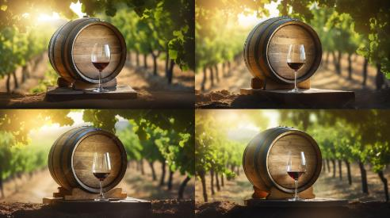 | vine barrel, wooden, aged, round, curved, cobweb covered, weathered, full, rustic, vineyard, green, leafy, verdant, rolling hills, crisp air, clear sky, serene, peaceful, tranquil, bottle, dark glass, label, vintage, elegant, wine glass, crystal, clear, stemmed, afternoon light, warm, soft, golden, technical details, camera model, aperture, ISO, shutter speed, depth of field, bokeh effect --ar 16:9 --v 5
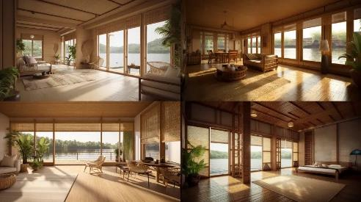 | waterfront bamboo bungalow interior, natural bamboo walls, woven bamboo flooring, bamboo furniture, tropical plants, flowing curtains, panoramic view of the water, serene atmosphere, simple and minimalist design, light and airy feel, organic textures, earthy color palette, 3D model, high-resolution, Sony camera, natural lighting --ar 16:9 --v 5
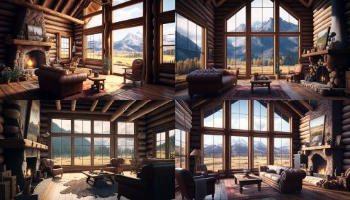 | interior shot of large rustic log cabin living room with a fireplace and large windows overlooking beautiful mountain valley landscape, 8k, realistic, intricate detail --ar 16:9 --v 4
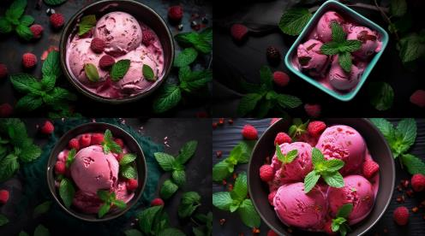 | raspberry ice cream with mint leaves as decoration, seen from above, creamy, sweet, refreshing, colorful, tasty, delightful, dessert, summer --ar 16:9 --v 5
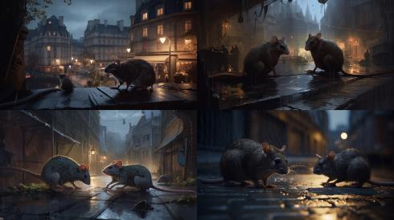 | Two rats in a street of a big city like Paris, locked in a battle over a scrap of food. Their sharp claws and teeth bared, they fight fiercely, oblivious to the bustling city around them. The street is dark, with only a few flickering streetlights illuminating the scene. The rats' eyes gleam in the dim light, adding to the intense atmosphere of the scene. Photographed by Martin Parr, using a Leica M10 with a 35mm lens, the lighting is a mix of natural light and colored gels, creating a moody and dramatic effect --ar 16:9 --v 5
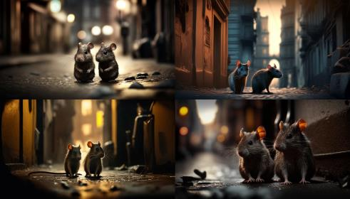 | Two rats in a street of a big city like Paris, furry, brown and grey, sneaky, fast, nocturnal, bustling, noisy, bright, illuminated, dirty, smelly, eerie, mysterious, technical, digital, cinematic, grainy, high contrast, shallow depth of field, DSLR camera model --ar 16:9 --v 4
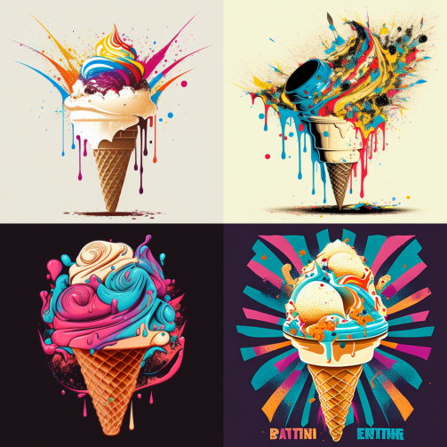 | Ice Cream Sundae::2 Futurism, Pointillism, Graphic Design, Color Wheel, Minimalism, synthwave:: T-Shirt Vector, Center Composition Graphic Design, Plain Background::2 Mockup::-2 --upbeta --ar 1:1 --v 4
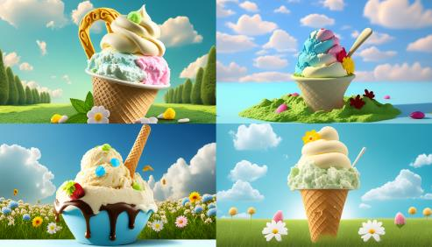 | Create an image of one scoop of vanilla ice cream. Describe it in detail, including its texture, color, and shape. Surround the ice cream with a vibrant, summery environment, with elements like green grass, colorful flowers, and a bright blue sky. The mood of the scene should be joyful and carefree, evoking the feeling of a relaxing summer day. Realize the prompt through a high-resolution photograph, using a macro lens to capture the intricate details of the ice cream and a shallow depth of field to blur the background. Use a camera with settings of f/2.8, ISO 100, and a shutter speed of 1/200s --ar 16:9 --v 4
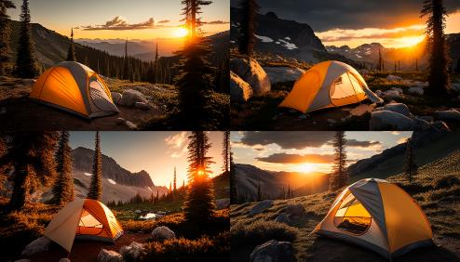 | A camping tent with travel bags and hiking gear set up in a serene mountainous environment. The tent is pitched on a flat ground with tall trees surrounding it. The sun is setting in the sky, casting a golden-orange hue on the landscape. The atmosphere is calm and peaceful, with a slight chill in the air. The image should be captured in a wide-angle shot, showcasing the entire scene in vivid detail. Use a DSLR camera with a 24-70mm lens, set at f/8, ISO 100, and a shutter speed of 1/125 sec to achieve maximum sharpness and clarity. --ar 16:9 --v 4
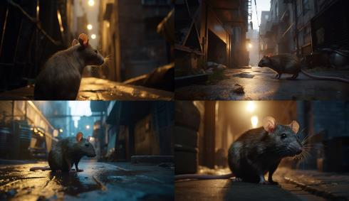 | a rat looking up and in an alley, in the style of science-fiction dystopias, 8k resolution, raw versus finished, rich and immersive, rtx on, depictions of animals, golden light --ar 26:15 --v 5
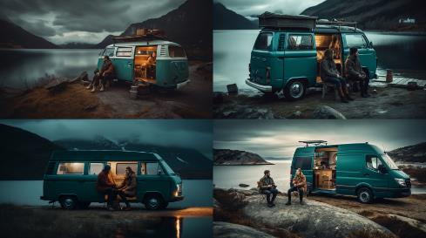 | woman and man sitting in van near the water with coffee, in the style of dramatic landscapes, dark turquoise and light amber, photo taken with provia, norwegian nature, rustic materiality, charming characters, cinestill 50d --ar 16:9 --v 5
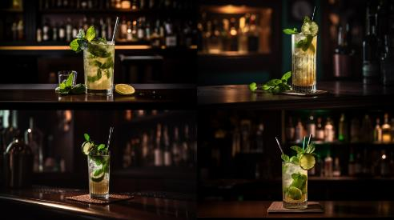 | A stunning photograph of a delicious mojito cocktail in a classy bar setting, with fresh mint leaves and lime wedges visible in the drink, the drink adorned with a stylish paper straw and served in a sleek glass with intricate details, surrounded by the ambient light of the cocktail bar with warm tones and a cozy atmosphere --ar 16:9 --v 5
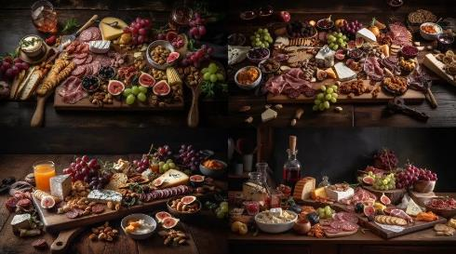 | A beautiful photo of a charcuterie board on a wooden table, surrounded by a collection of cured meats, artisanal cheeses, nuts, crackers, and fruits. The scene is set for an gathering of friends, with wine glasses and a bottle of red wine ready to be uncorked and savored. The board is arranged to showcase the diverse and colorful array of offerings, with a rustic, organic feel. The lighting is warm and inviting, with shadows and highlights casting an inviting glow on the scene. The shallow depth of field creates a dreamy effect, drawing the viewer's focus to the centerpiece of the table. This photo captures the essence of a relaxed, convivial moment, where good food, good drink, and good company come together in perfect harmony --ar 16:9 --v 5
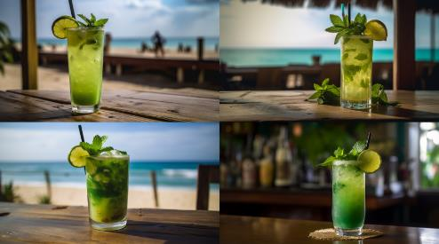 | A professional photo of a classic mojito cocktail, with the vibrant green mint leaves and sparkling clear liquid contrasting against the warm golden sand and deep blue sea of a tropical beach bar. The photo captures the essence of relaxation and vacation, with a tropical palm tree in the background and a wooden bar in the foreground, complete with a chalkboard menu and a variety of exotic cocktails. A frosty glass of mojito, garnished with a wedge of lime and fresh mint leaves, stands front and center, inviting the viewer to imagine taking a sip and savoring the sweet and tangy flavors. The photo boasts excellent clarity and sharp focus, with a shallow depth of field that creates a soft, dreamy effect --ar 16:9 --v 5
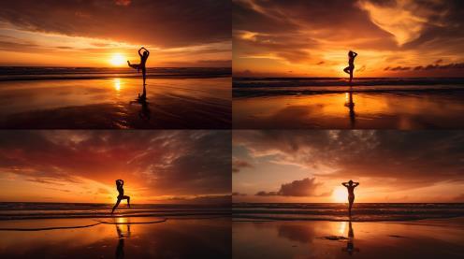 | A striking photo of a silhouette of a person doing a yoga pose on a windswept beach at sunset, with the sky ablaze in warm shades of yellow and red, and the waves crashing against the shore, 8k --ar 16:9 --v 5
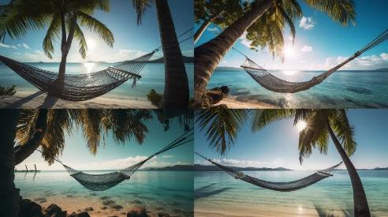 | A tranquil photograph of a hammock, strung between two tall and elegant palm trees, overlooking the sunlit ocean. The hammock's gentle swaying is captured in the photograph, conveying a sense of calm and relaxation. The bright blue sky and sparkling turquoise waters create a beautiful and inviting backdrop to the scene, 8k --ar 16:9 --v 5
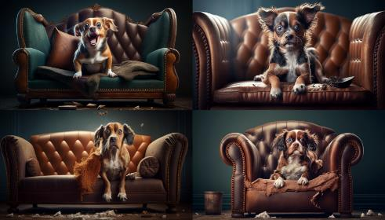 | A hilarious photo of a mischievous dog with a guilty expression, caught in the act of ripping apart a luxurious leather sofa with reckless abandon. The image has a warm and cozy atmosphere, with plenty of natural light, showcasing the playful dog and the ruined furniture, 8k --ar 16:9 --v 4
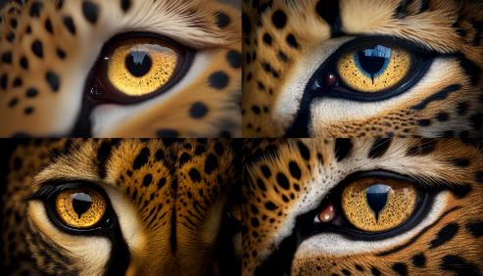 | Beautiful photo of a fierce majestic Cheetah’s eyes, extreme macro close up of an eye, black background, 8k --ar 16:9 --v 4
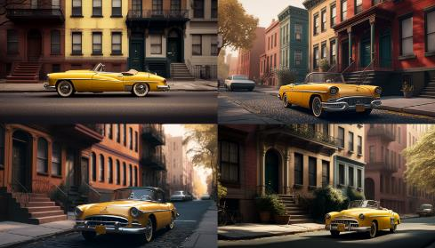 | A yellow 1950s convertible cruising down a quiet residential street in Brooklyn, the car's top down and the wind blowing through the driver's hair. The vibrant color of the car contrasts with the muted tones of the surrounding buildings, and the serene atmosphere adds a touch of calm to the scene, 8k --ar 16:9 --v 4
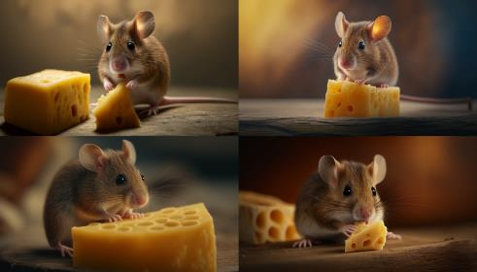 | A captivating photo of a little brown mouse perched on a wedge of yellow cheese, nibbling away with a look of contentment on its face, captured in high definition, 8k --ar 16:9 --v 4
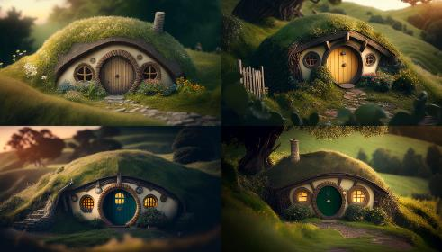 | A whimsical photograph of a cozy hobbit house nestled in a lush, green hillside, with a thatched roof and round, wooden door. The warm glow from the windows welcomes visitors into the charming abode. The image has a shallow depth of field and a soft, dreamy quality, evoking a sense of peace and tranquility, 8k --ar 16:9 --v 4
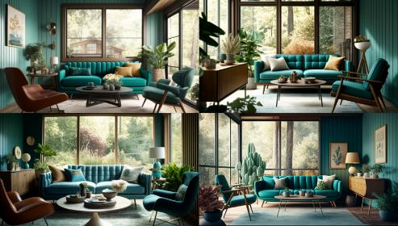 | A cozy mid-century modern living room featuring a teal-colored sofa, vintage wooden armchairs, and a sleek coffee table with metal accents, set against a backdrop of light-colored wooden walls and large windows overlooking a lush garden outside. The room is bathed in warm sunlight, with soft, earthy tones that evoke a sense of calm and relaxation, 8k --ar 16:9 --v 4
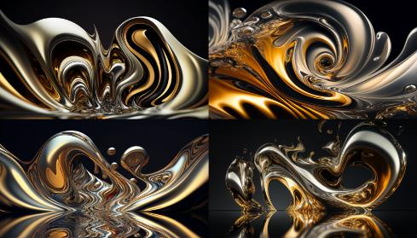 | A mesmerizing photo of abstract liquid metal in motion, with swirls and eddies of silver and gold forming intricate patterns and shapes. The photo captures the fluidity and texture of the liquid metal, with ripples and waves creating a sense of dynamic motion and energy, 8k --ar 16:9 --v 4
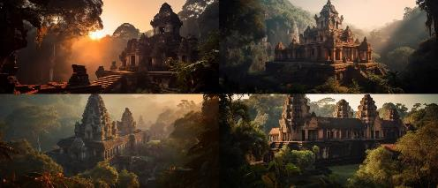 | A breathtaking photo of an ancient temple nestled deep in a tropical jungle, with intricate details and vivid textures on the temple walls, a towering central spire, and a sprawling network of smaller buildings and courtyards surrounding it. Captured during the golden hour, with the soft orange and yellow hues of the sun casting a warm glow across the temple's aged stone, emphasizing the intricate carvings and reliefs of the ancient civilization that built it, 8k --ar 21:9 --v 5
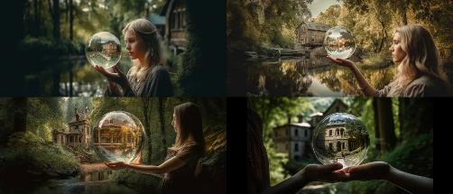 | An enchanting photograph of a woman holding a crystal ball in her hands, with an image of her future home visible inside the ball. The natural environment surrounding the home is captured in exquisite detail, with vibrant green foliage, towering trees, and a gentle stream flowing nearby. The woman's expression is one of wonder and amazement, as if she can hardly believe the beauty of the scene before her. The lighting is soft and warm, adding a sense of magic and enchantment to the image, 8k --ar 21:9 --v 5
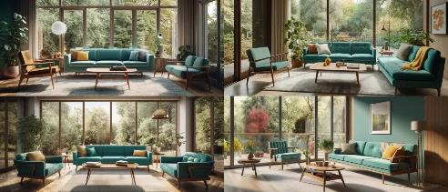 | A cozy mid-century modern living room featuring a teal-colored sofa, vintage wooden armchairs, and a sleek coffee table with metal accents, set against a backdrop of light-colored wooden walls and large windows overlooking a lush garden outside. The room is bathed in warm sunlight, with soft, earthy tones that evoke a sense of calm and relaxation, 8k --ar 21:9 --v 5
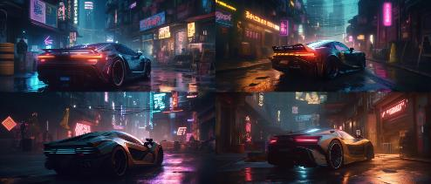 | An electrifying photograph of a high-performance cyberpunk sports car, weaving through the busy and densely populated streets of a futuristic metropolis, the car's LED lighting and angular design complementing the city's neon-soaked, sci-fi aesthetic, 8k --ar 21:9 --v 5
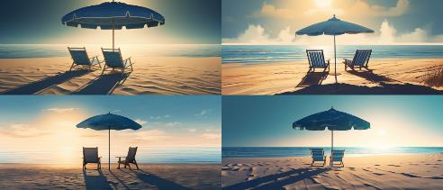 | An artistic rendering of a tranquil beach scene, featuring a single striped beach umbrella casting a playful shadow across two empty chairs on the sand. The sea in the background is painted in varying shades of blue, with the sun casting a warm glow on the horizon. The overall effect is a serene and calming image that evokes memories of lazy summer days, 8k --ar 21:9 --v 5
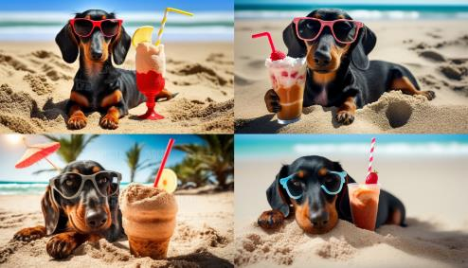 | Beautiful dog of dachshund, black and tan, buried in the sand at the beach sea on summer vacation holidays, wearing red sunglasses with coconut cocktail stock photo Summer, Dog, Vacations, Beach, Humor, 8k --ar 16:9 --v 4
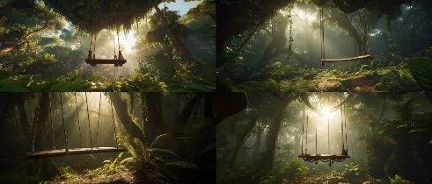 | A picturesque scene of a wooden jungle swing, suspended from a tall tree, swinging gently amidst the vibrant green foliage of the rainforest. The lush vegetation forms a natural canopy, filtering the sunlight to cast a warm, dreamlike glow over the scene. The viewer's perspective is from below, looking up at the swing, creating a sense of immersion and wonder, 8k --ar 21:9 --v 5
 | A fun and whimsical image of a hippopotamus lying lazily on an inflated pool mattress, floating atop the calm blue waters of the ocean. The sun beats down on the scene, casting a warm glow on the water and the hippo's body, creating a sense of relaxation and contentment, 8k --ar 21:9 --v 5
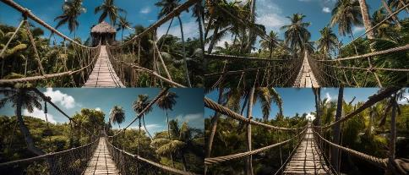 | An adventurous photo of a rope bridge suspended between two towering palm trees, swaying gently in the breeze. The bright blue sky serves as the backdrop for the image, and the lush green foliage of the surrounding trees provides a stunning contrast to the weathered ropes and wooden planks of the bridge, 8k --ar 21:9 --v 5
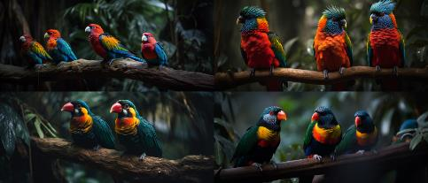 | A stunning close-up photo of exotic birds perched on branches in a tropical forest. The birds are vividly colored, with intricate feathers and sharp beaks. The photo captures their beauty and grace, with the leaves and branches of the trees providing a natural and colorful backdrop, 8k --ar 21:9 --v 5
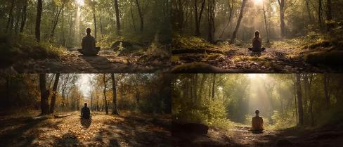 | A serene photo of a person meditating in a sun-dappled clearing. The person is sitting cross-legged on a mat, with their eyes closed and their hands resting on their knees. The clearing is surrounded by trees, with the sun filtering through the leaves, casting warm, dappled light on the person and the surrounding foliage, 8k --ar 21:9 --v 5
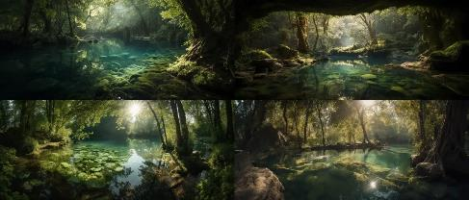 | A magical photo of a natural pool nestled in the heart of a forest. The pool is surrounded by lush greenery, with the leaves and branches of the surrounding trees creating a natural canopy overhead. The water is crystal clear, with sunlight filtering through the trees, casting intricate patterns of light and shadow on the surface of the water, 8k --ar 21:9 --v 5
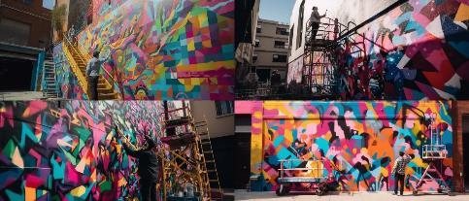 | A shot of a street artist working on a colorful mural on the side of a building in a bustling city. The artist is wearing paint-splattered clothes and is standing on a tall ladder, painting with a roller and a brush. The mural is abstract and colorful, with geometric shapes and patterns in bright pink, yellow, and blue, 8k --ar 21:9 --v 5
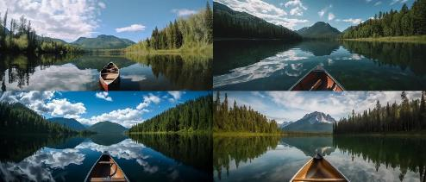 | A wide-angle shot of a canoe gliding across a calm lake surrounded by trees and mountains. The shot is taken from a low angle, capturing the entire scene and the reflection of the mountains and trees in the water. The canoe is in the foreground, with a couple paddling and enjoying the serene surroundings. The sky is blue with a few wispy clouds, and the sun is casting a warm glow on the scene, 8k --ar 21:9 --v 5
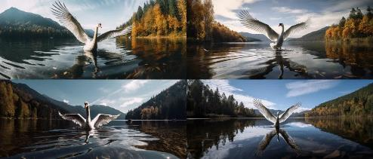 | A wide-angle shot of a majestic swan swimming near the shore of a serene lake. The shot is taken from a low angle, capturing the entire scene and the reflection of the swan in the water. The swan is in the foreground, with its wings spread wide and its feathers ruffling in the breeze. The lake is surrounded by trees and mountains, adding a sense of serenity to the scene, 8k --ar 21:9 --v 5
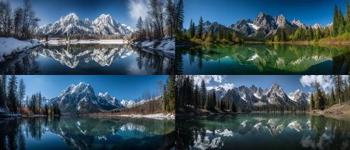 | A wide-angle shot of a breathtaking reflection of the mountains on the water. The shot is taken from a low angle, capturing the entire scene and the reflection of the mountains in the water. The water is calm and still, reflecting the majestic peaks and blue sky. The mountains are covered in snow and surrounded by tall trees, adding a sense of grandeur to the scene, 8k --ar 21:9 --v 5
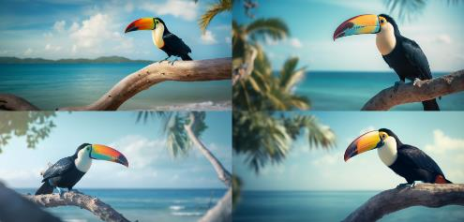 | An incredible photograph of a toucan bird perched on a branch with a beautiful beach in the background. The bright colors of the bird's feathers pop against the soft blue of the sky and sea. The photo is taken from a low angle, emphasizing the bird's size and majesty, 8k --ar 21:10 --v 5
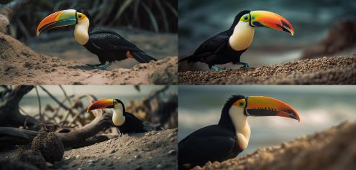 | A stunning photograph of a toucan bird in its natural habitat, captured in stunning detail, with a pristine beach in the background. The photo captures the intricate details of the bird's colorful feathers and the textures of the sand and rocks on the beach, 8k --ar 21:10 --v 5
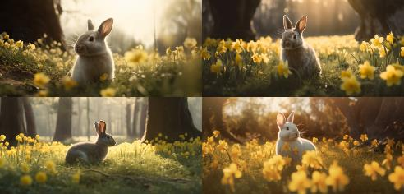 | A high-quality photograph of an adorable bunny sitting in a field of yellow daffodils, the sunlight filtering gently through the trees in the background, casting a soft glow on the scene, 8k --ar 21:10 --v 5
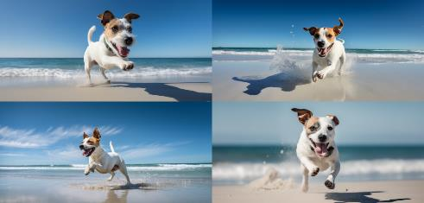 | A stunning photograph of a Jack Russell Terrier with short, wiry fur, playfully jumping in the air while chasing a colorful ball on a pristine, white sand beach. The photograph is taken at eye level, with the turquoise waves and bright blue sky providing a picturesque background. The dog's tongue is lolling out in excitement, and his tail is wagging energetically, capturing the joy of a perfect day at the beach, 8k --ar 21:10 --v 5
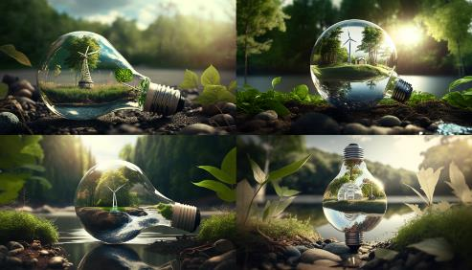 | Nature in a bulb, sustainability and renewable energy concept, solar panels, wind turbines, green leaves, eco-friendly, earth-friendly, environment, lush forest, clean river, blue sky, sunlight, fresh air, peaceful, serene, calming, inspiring, eco-conscious, Blender, 3D rendering, ray-tracing, depth of field, wide-angle lens, high-resolution, realistic textures, night, moonlight, stars, shadows, silhouettes, materials, glass, metal, organic, translucent, camera settings, ISO, aperture, shutter speed, focal length, 8k --ar 16:9 --v 4
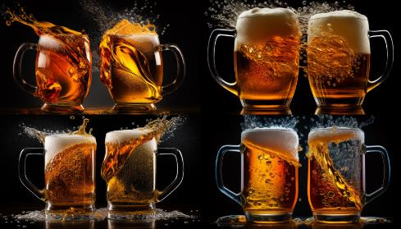 | Two beer mugs clashing, frothy, cold, refreshing, amber, liquid, glass, handle, celebration, toast, cheers, camaraderie, socializing, pub, bar, friends, fun, laughter, lively, atmosphere, convivial, Nikon, DSLR, high shutter speed, wide aperture, autofocus, crisp, sharp, vibrant colors, 8k --ar 16:9 --v 4
T-Shirt Design
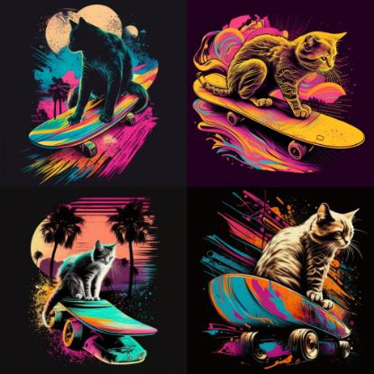 | cat on skateboard::2 Psychedelic, lettering, color theory, gradients, surrealism, synthwave:: t-shirt vector, center composition graphic design, plain background::2 mockup::-2 --upbeta --ar 1:1 --v 4
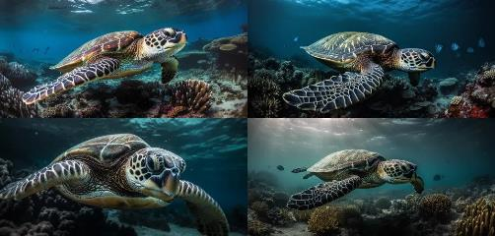 | A breathtaking photograph of a sea turtle gracefully swimming underwater in the Great Barrier Reef. The turtle is captured in stunning detail, with its intricate shell, flippers, and scales in full view, as well as the vibrant coral and marine life surrounding it, 8k --ar 21:10 --v 5
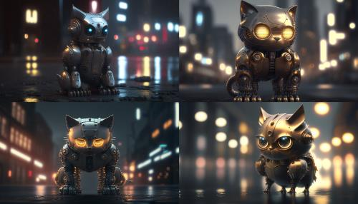 | robot cat, metal, shiny, robotic, cute, night, cityscape, futuristic, dark, moody, urban, rendering engine, 3D model, f/2.8 aperture, 1/100 shutter speed, 8k --ar 16:9 --v 4
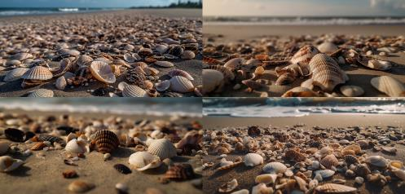 | A close-up photograph of several seashells scattered on the wet sand of a beach, with the ocean waves visible in the background. The seashells are of different shapes, sizes, and colors, with intricate patterns and textures. The photo is shot from a low angle to create a sense of depth and immersion, 8k --ar 21:10 --v 5
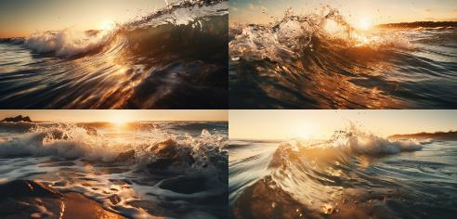 | A mesmerizing photo of the waves crashing against the shore, shot from a low angle to capture the power and intensity of the water. The photo is taken during golden hour, with the sunlight creating a beautiful warm glow on the water's surface. The waves are in motion, with the frothy white water creating a sense of movement and energy, 8k --ar 21:10 --v 5
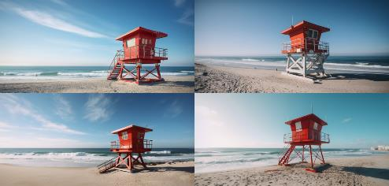 | High-quality photograph of a red and white lifeguard tower standing tall against a clear blue sky, with the shimmering ocean waves crashing in the background, 8k --ar 21:10 --v 5
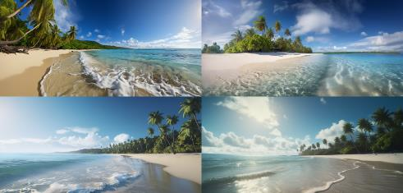 | A breathtaking photograph of a serene beach, surrounded by tall palm trees with their fronds gently swaying in the sea breeze. The crystal-clear waters gently lap at the pristine sand, while fluffy white clouds dot the azure sky, casting soft shadows over the landscape, 8k --ar 21:10 --v 5
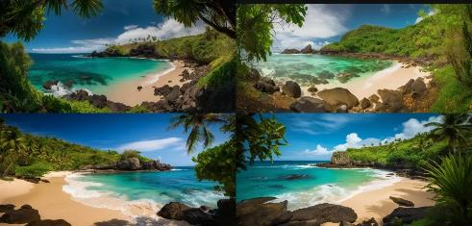 | A striking photograph of a secluded cove, with lush greenery and exotic vegetation providing an emerald-hued frame to the sandy beach. The palm trees and other tropical foliage are captured with sharp detail, and their vibrant colors and intricate textures pop against the calm blue waters of the ocean, 8k --ar 21:10 --v 5
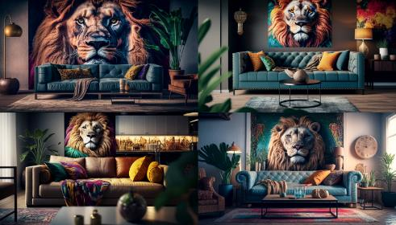 | wild living room with sofa with lion portrait, eclectic, vibrant, exotic, textured, patterned, bold, daring, adventurous, comfortable, luxurious, playful, colorful, spacious, energetic, fierce, untamed, modern, digital, wide angle lens, HDR, ambient lighting, color grading, 8k --ar 16:9 --v 4
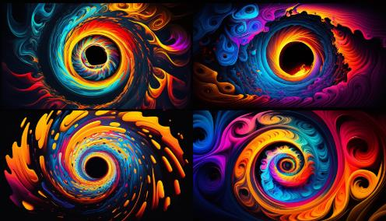 | A digital art piece with an array of bright colors such as neon pink, electric blue, sunny yellow, and fiery orange, blending seamlessly together in a hypnotic whirlpool. The background is black, further intensifying the vividness of the colors, 8k --ar 16:9 --v 4
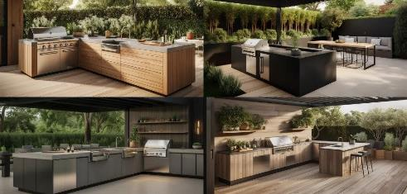 | A stunning photograph of an expertly designed outdoor kitchen, featuring a built-in grill and sink, and a comfortable seating area that invites you to enjoy the perfect combination of cooking and dining alfresco. The sleek and modern design blends seamlessly with the surrounding landscape, while the thoughtful layout ensures that everything is within reach for effortless entertaining, 8k --ar 21:10 --v 5
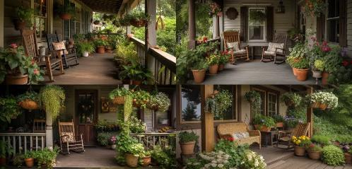 | photo of a porch with two wooden rocking chairs, adorned with plush cushions, surrounded by potted ferns and flowering plants in various ceramic pots, with two large hanging baskets overflowing with cascading flowers adding a charming touch of color and texture to the scene, 8k --ar 21:10 --v 5
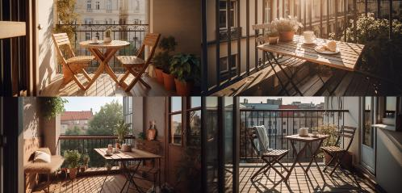 | A balcony with a small table and chairs for enjoying a morning coffee or evening drink, cozy, wooden, sunny, peaceful, charming, relaxing, outdoors, natural, scenic, happy, warm, romantic, vintage, summery, comfortable, modern, minimalist, urban, 8k --ar 21:10 --v 5
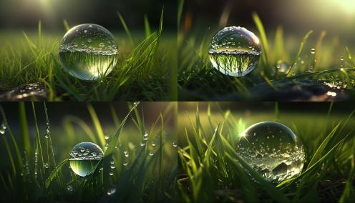 | A beautiful large drop of morning dew in the grass sparkles in the rays of sunlight outdoors in nature, A drop of water on a blade of grass and free space for text, Sparkling, transparent, round, reflective, fresh, green, lush, natural, peaceful, serene, tranquil, calming, mood-enhancing, Render engine: Ray tracing, Camera model: DSLR, Camera settings: f/2.8, 1/250s, ISO 100, 8k --ar 16:9 --v 4
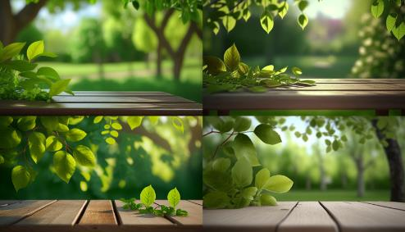 | Spring beautiful background with green juicy young foliage and empty wooden table in nature outdoor, lush, vibrant, fresh, colorful, natural, serene, peaceful, refreshing, outdoors, daylight, foliage, trees, leaves, grass, atmosphere, mood, feelings, joyful, happy, cheerful, delightful, content, technical, 3D render engine, Nikon camera model, aperture priority mode, ISO 100, focal length 50mm, high-resolution image, 8k --ar 16:9 --v 4
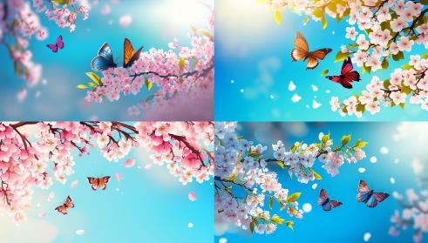 | Spring banner, branches of blossoming cherry against background of blue sky and butterflies on nature outdoors. Pink sakura flowers, dreamy romantic image spring, landscape panorama, copy space, beauty, elegance, delicate, fragrant, natural, peaceful, serene, vibrant, colorful, fresh, crisp, clear, sunny, breezy, tranquil, joyful, playful, romantic, dreamy, idyllic, picturesque, inviting, welcoming, charming, enchanting, mystical, magical, tender, soft, graceful, smooth, detailed, realistic, high-quality, 3D-rendered, digital, camera model: Canon EOS 5D Mark IV, aperture: f/4, shutter speed: 1/320s, focal length: 105mm, ISO: 400, 8k --ar 16:9 --v 4
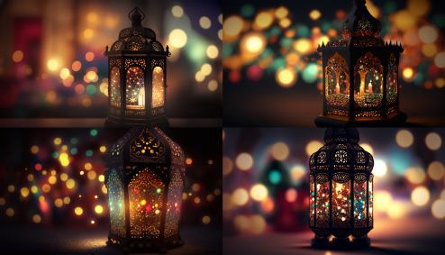 | Original traditional ornate oriental lantern with beautiful bokeh of holiday lights and mosque in background, intricate, colorful, delicate, ornamental, antique, vintage, cultural, festive, cheerful, night, holiday lights, mosque, stars, darkness, mystical, magical, atmospheric, technical, digital, high-quality, professional, render engine, camera model, aperture, exposure time, 8k --ar 16:9 --v 4
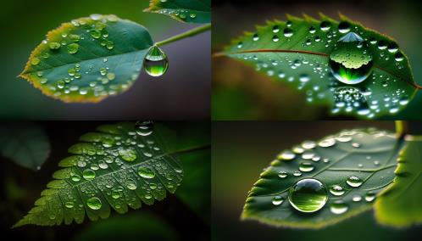 | Large drop water reflects environment, Nature spring photography — raindrops on plant leaf. Water drop, Large, Reflective, Environment, Nature, Spring, Photography, Raindrops, Plant Leaf, Forest, Trees, Foliage, Moisture, Wet, Damp, Fresh, Vibrant, Green, Calm, Serene, Peaceful, Tranquil, Relaxing, Refreshing, Soothing, Technical, DSLR, High Resolution, Shutter Speed, Aperture, ISO, Macro Lens, 8k --ar 16:9 --v 4
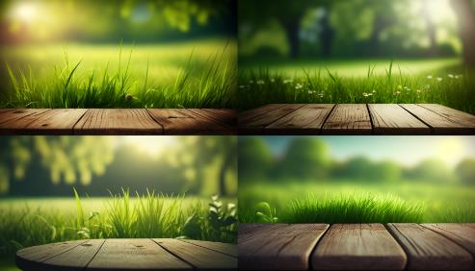 | Beautiful spring natural background with green fresh juicy young grass and empty wooden table in nature morning outdoor, beauty, freshness, vibrancy, natural, outdoor, morning, nature, calm, serene, peaceful, refreshing, new, awakening, camera, bright, sharp, detailed, realistic, 8k --ar 16:9 --v 4
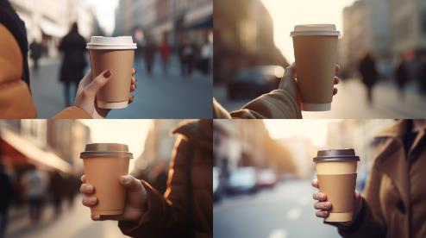 | Female hand holding a paper cup of coffee, to-go style, hot and steaming, portable, convenient, modern, a symbol of busy urban life, depicting a woman on the go, her hand steady and confident, holding the cup with ease, paper sleeve protecting her hand from the heat, brown cardboard texture contrasting with her skin, in the background, a blurred city street, with skyscrapers and cars, suggesting a bustling metropolis, a busy lifestyle, a sense of movement and activity --v 5 --ar 16:9 --v 4
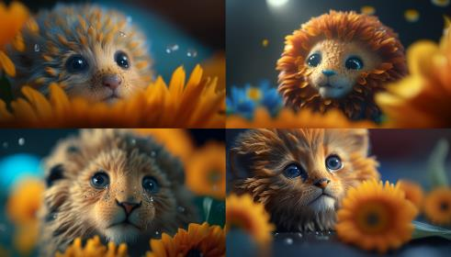 | a tiny lion with orange daisy petals for his mane, macro lens focus on the lion’s head and daisy petals, surreal, playful, happy, colorful, water droplet details on the petals, and bokeh, dynamic composition and dramatic lighting, ultra-sharp, high-definition and 8K resolution, blue, orange, yellow, 8k --ar 16:9 --v 4
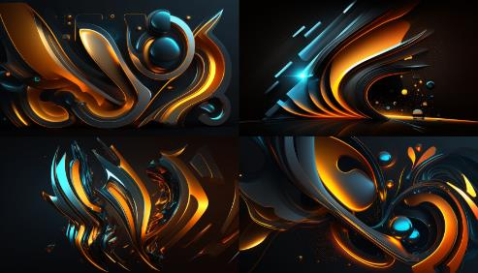 | Beautiful abstract futuristic background, dark and mysterious, evoking a sense of the unknown, the infinite, the possibilities of the future, featuring a neon blue and orange glow, bright and vivid, contrasting with the darkness, creating a mesmerizing and captivating effect, suggesting a world of technology, of innovation, of progress, of new frontiers, with shapes and forms that are dynamic and fluid, yet precise and geometric, conveying a sense of movement, of energy, of transformation, with a touch of surrealism and magic, a vision of a world beyond our current understanding and imagination, 8k --ar 16:9 --v 4
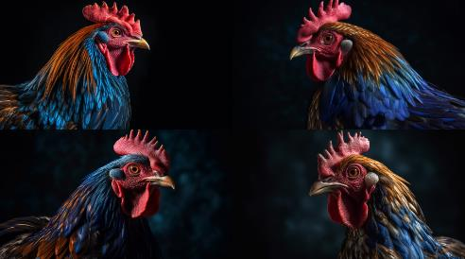 | a beautiful and colorful rooster in a dynamic portrait pose shot from an ultra-low low camera angle against a cobalt blue sweep. The photograph is highly detailed using a professional camera with a macro lens. It is ultra-sharp and 8K resolution featuring tight focus on the rooster’s head and eye, showcasing its intricate, shiny feathers, and rich textures. The lighting is dramatic and the composition is dynamic, tilt-shift angle with a shallow depth of field and a sharp focus on the rooster’s eye and head with bokeh in the background. Colors are cobalt blue, turquoise, yellow, orange, and red --v 5 --ar 16:9
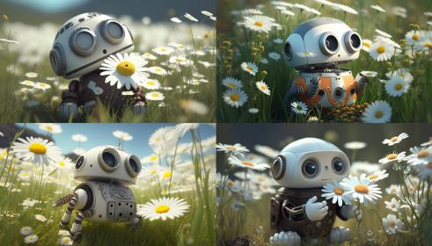 | baby robot smelling a flower in a field of daisies, small, curious, mechanical, colorful, soft, sunny, natural, peaceful, happy, cheerful, digital, high-resolution, 3D modeled, textured, ray-traced, photorealistic, 8k --ar 16:9 --v 4
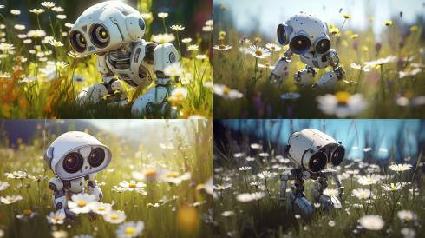 | baby robot smelling a flower in a field of daisies, small, curious, mechanical, colorful, soft, sunny, natural, peaceful, happy, cheerful, digital, high-resolution, 3D modeled, textured, ray-traced, photorealistic, 8k --ar 16:9 --v 5
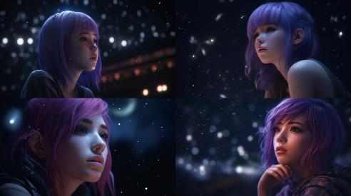 | Anime girl with purple hair, ethereal, mysterious, cute, floating, moonlit night, stars, mist, tranquil, pensive, dreamy, mystical, rendering engine: Unreal Engine 5, camera model: Sony A7S III, aperture: f/1.8, shutter speed: 1/60, ISO: 1600 --ar 16:9 --v 5
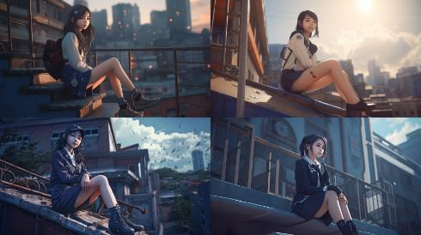 | A stunningly beautiful smiling high school Japanese girl wearing a mini-skirted high school uniform sitting on top of a building, in the style of fractalpunk, ray tracing, nightcore, detailed costumes, mysterious backdrops, 32k uhd, distorted, exaggerated figures, perfection, ultra-realistic, by Yigal Ozeri, Anne Dewailly --ar 16:9 --v 5
T-shirt design
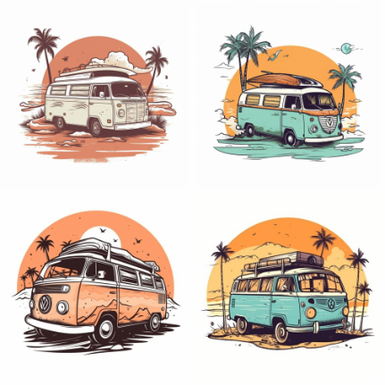 | travel van in front of a beach cartoon tshirt design graphic, vector, contour, isolated on a white background --ar 1:1 --v 5
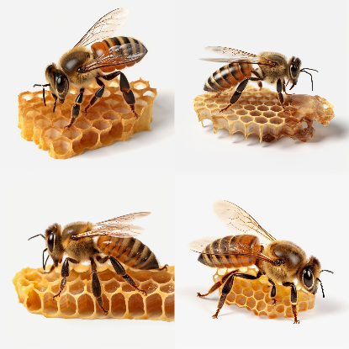 | bee on honey comb, isolated on transparent background cutout, 32k uhd --ar 1:1 --ar 16:9 --v 5
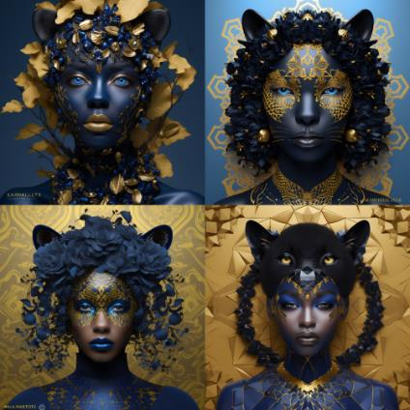 | Natalie Shau cinematic highly detailed Head and shoulders portrait of a beautiful black panther with emotive eyes is shown in an intelligently stylized sapphire and yellow fashion, optical illusion body art, chaotic matrix patterns, 3D illustrative paper art, intelligent use of composition, creative use of textures, unique repeating patterns --ar 1:1 --v 5
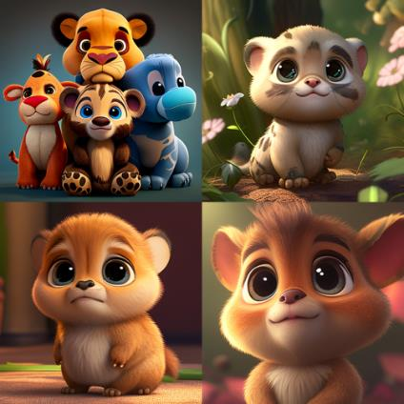 | Childrens cute disney style animation animal character in 8k high quality --ar 1:1 --v 4

For Upscale and Enhance your images I use this AI Tool. I think, it’s the best quality tool to work with Midjourney images.
You can also take this great course Midjourney for Beginners: Step-By-Step Guide to Generating AI Art.
Free 1 month trial period, with access to tens of thousands of other cool courses.

Good luck! 😉

